**DevOps | Assignment – 2**

**Bhavya Mistry| Roll No – 33**

ABC person plans to build a completely automated job to reduce the manual effort of deployment which gets triggered when a branch in the SCM is merged to master and the WAR file generated is deployed to the Tomcat web server automatically.

**Aim:** Build and Deploy war file of maven on tomcat server using Jenkins

**Procedure:**

**Step 1:** Installing and Configuring Tomcat  
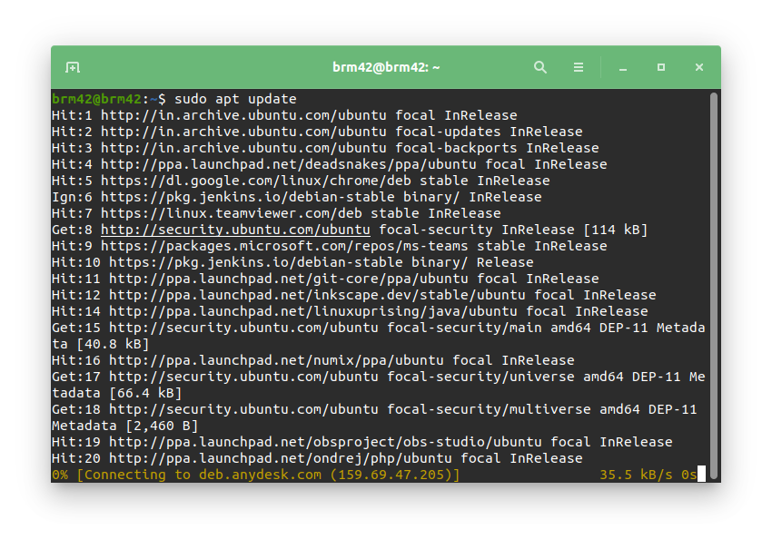

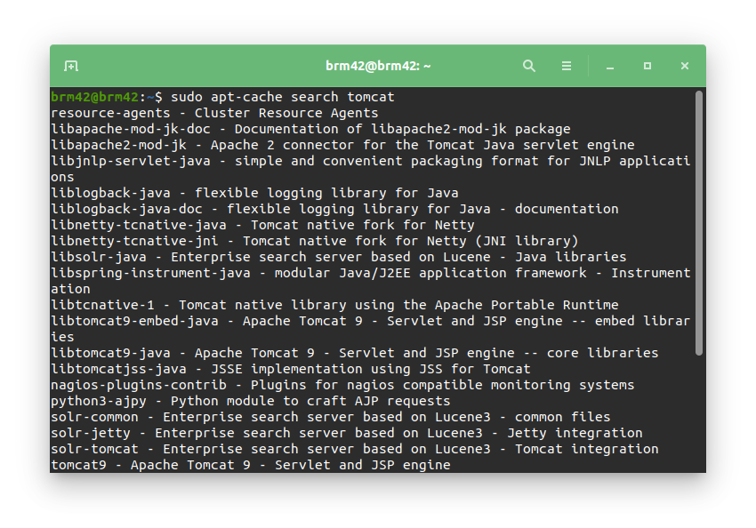

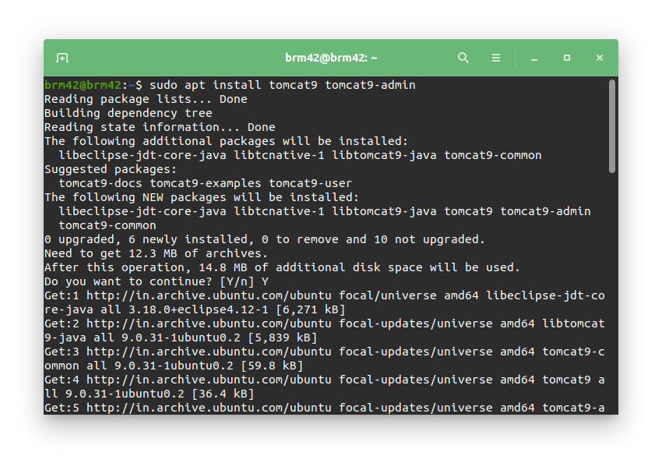

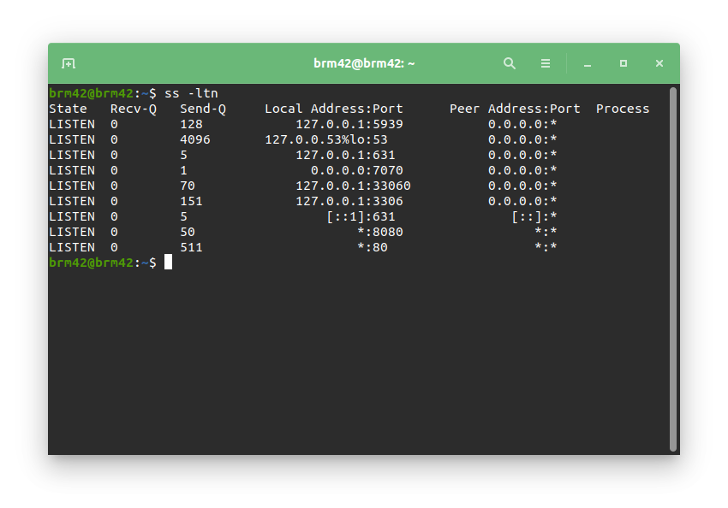

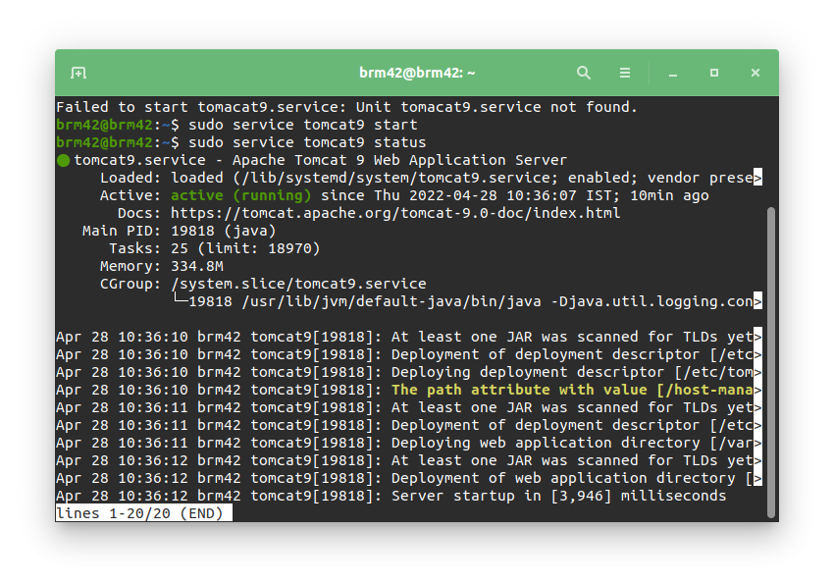

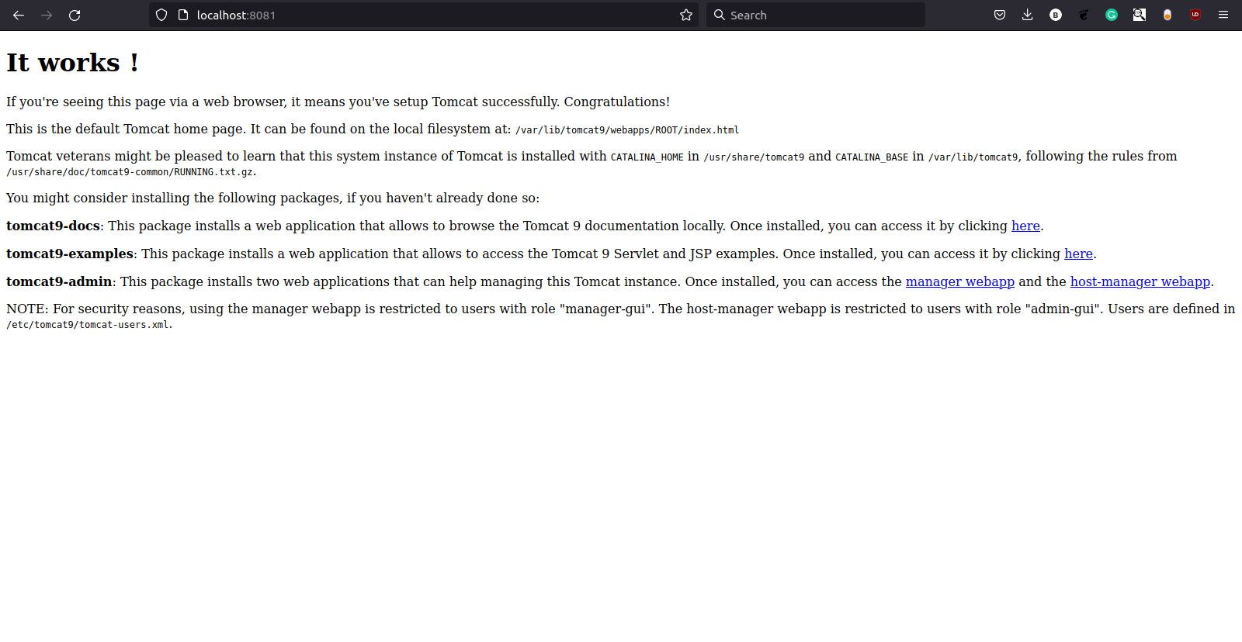

Step 2:

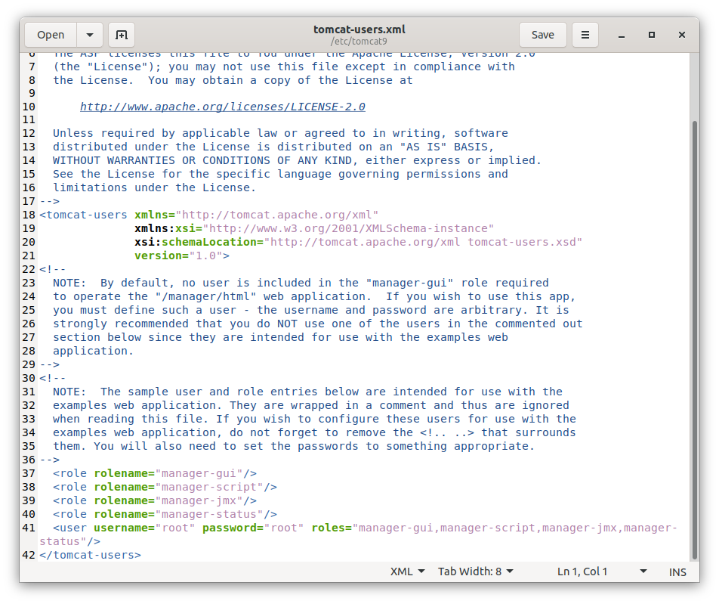

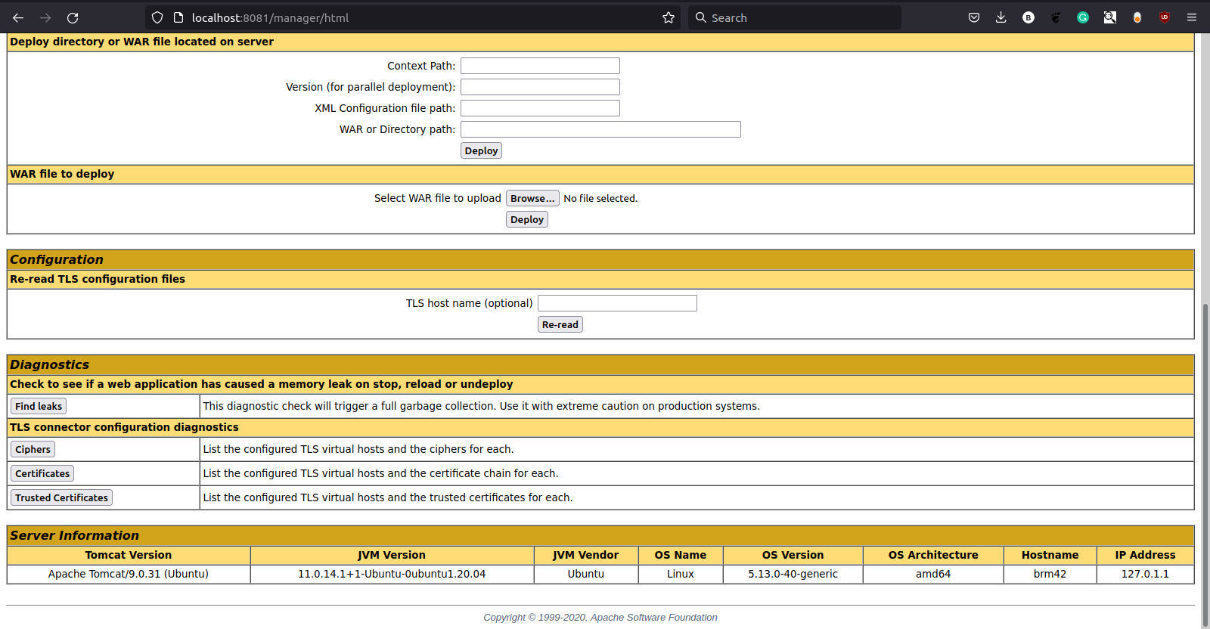

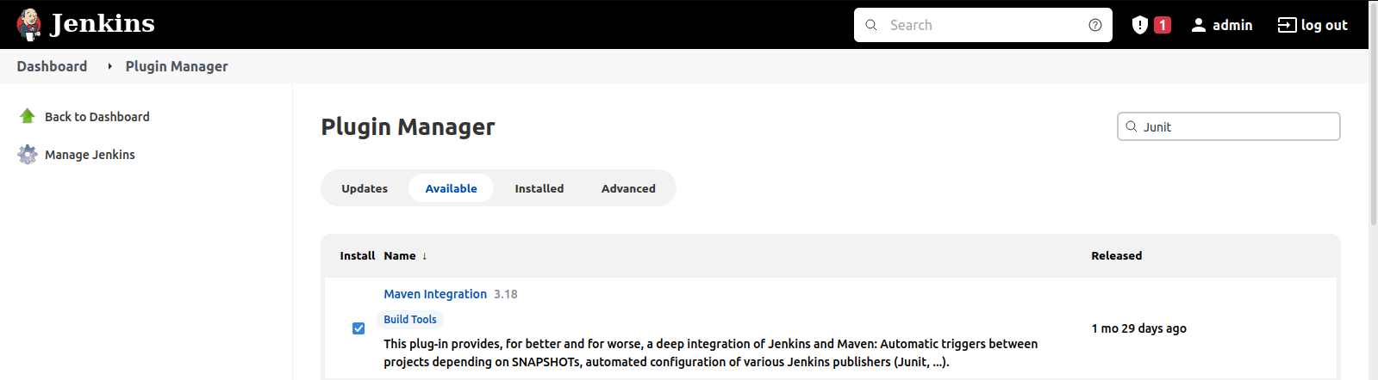

1. Installing “Deploy to container” plugin

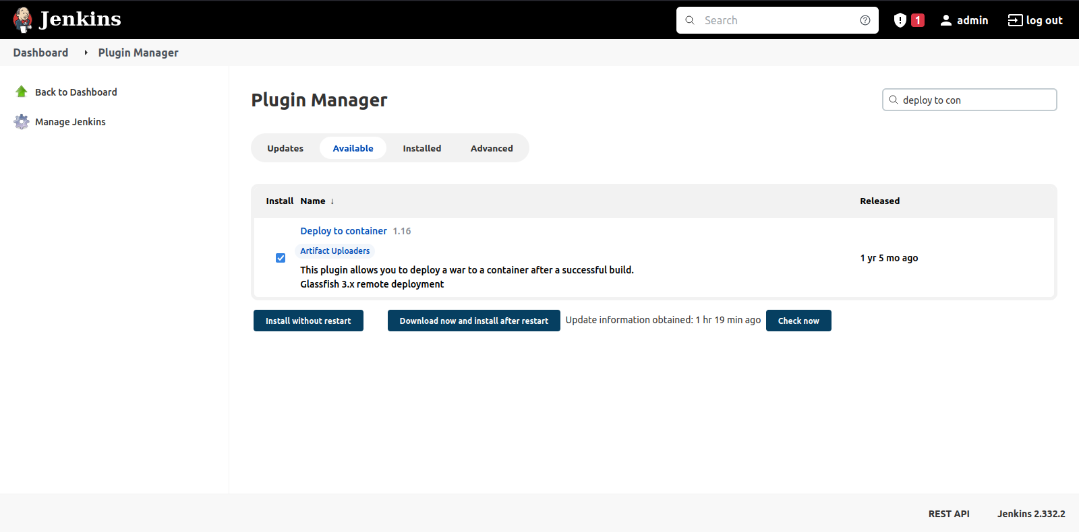

1. Pushing maven Project codes into GitHub

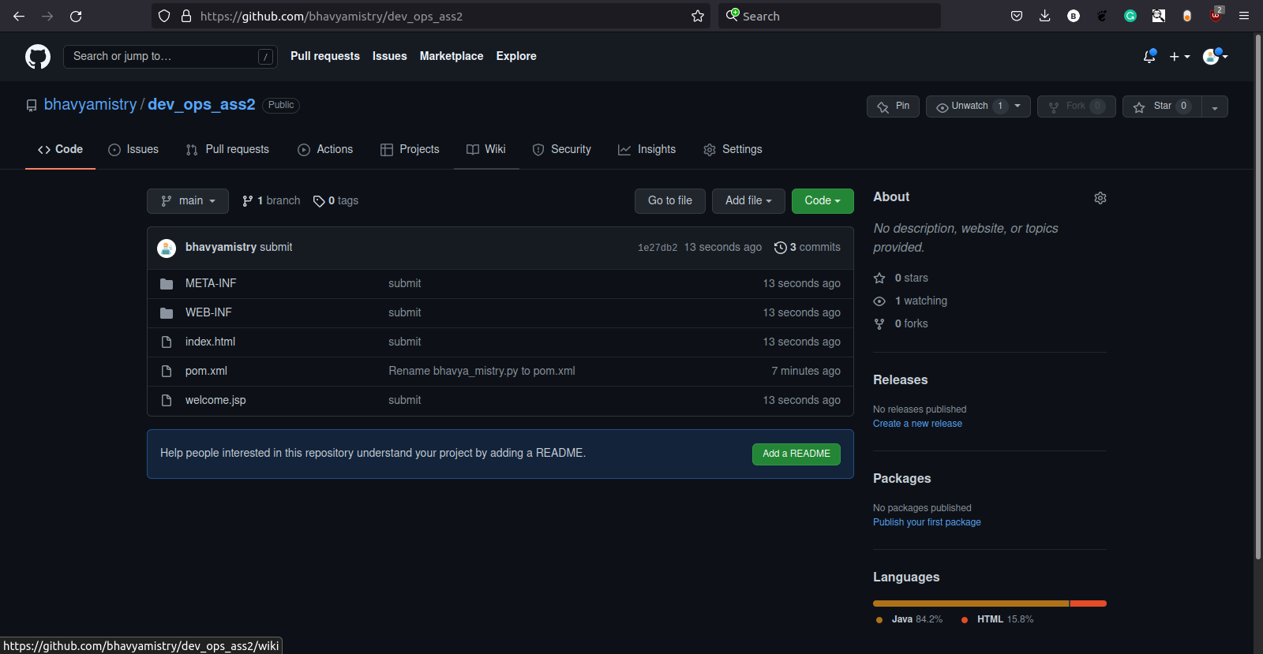

1. Creating new maven project on Jenkins

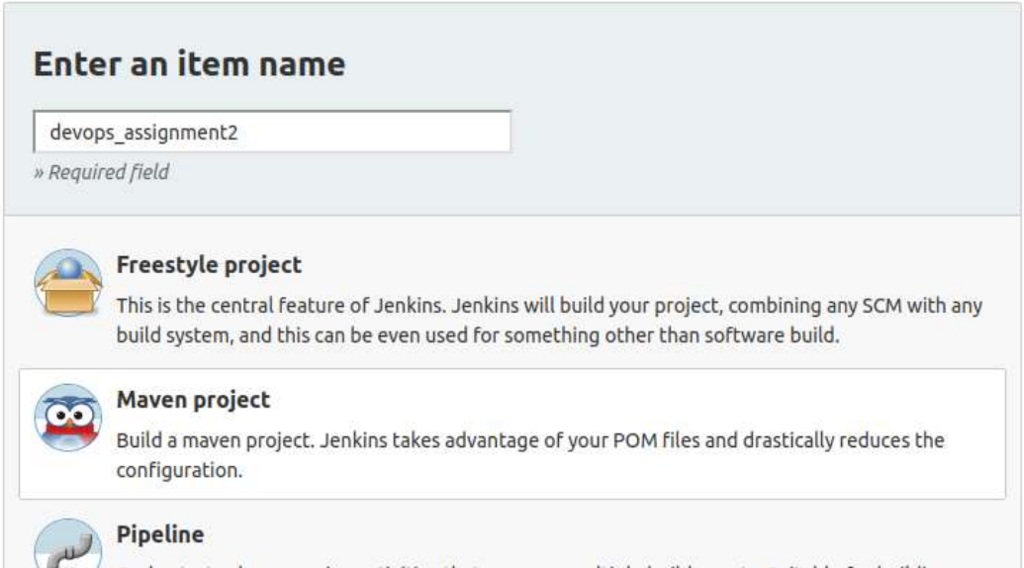

1. Configuring the project

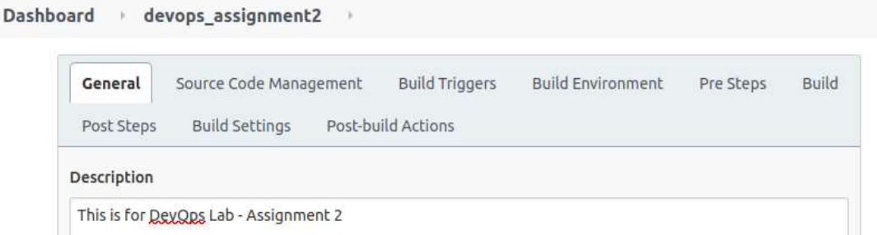

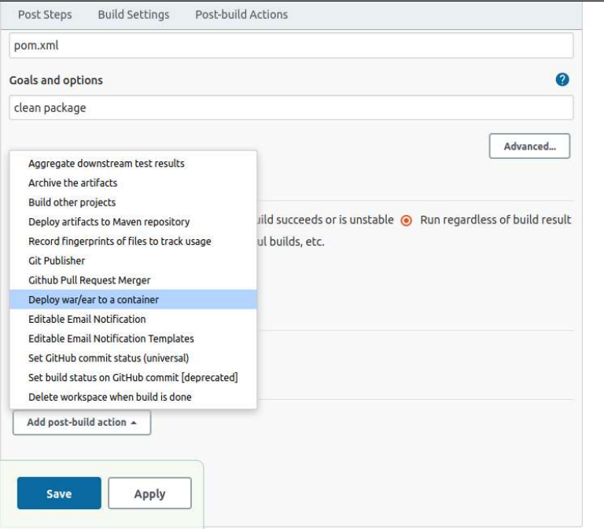

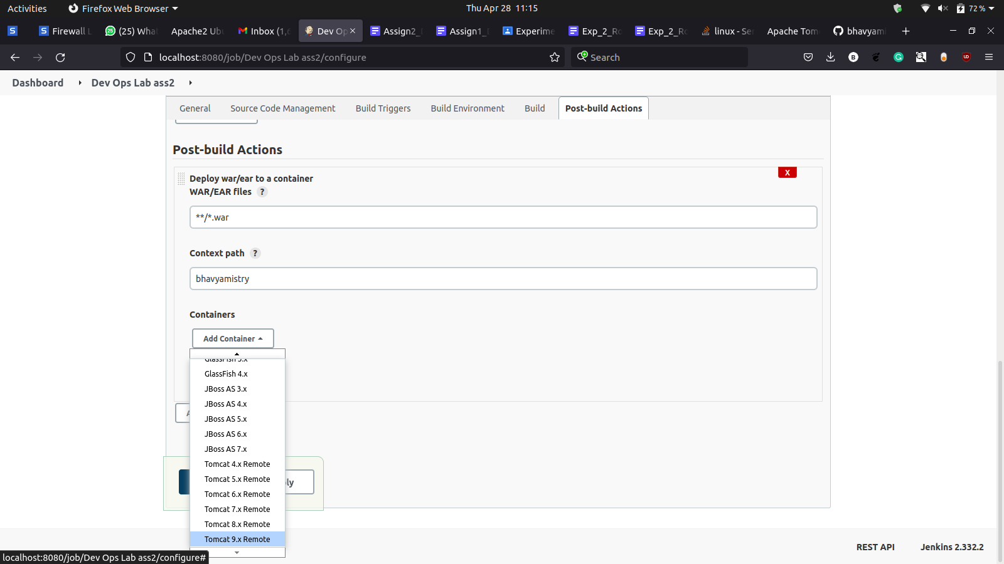

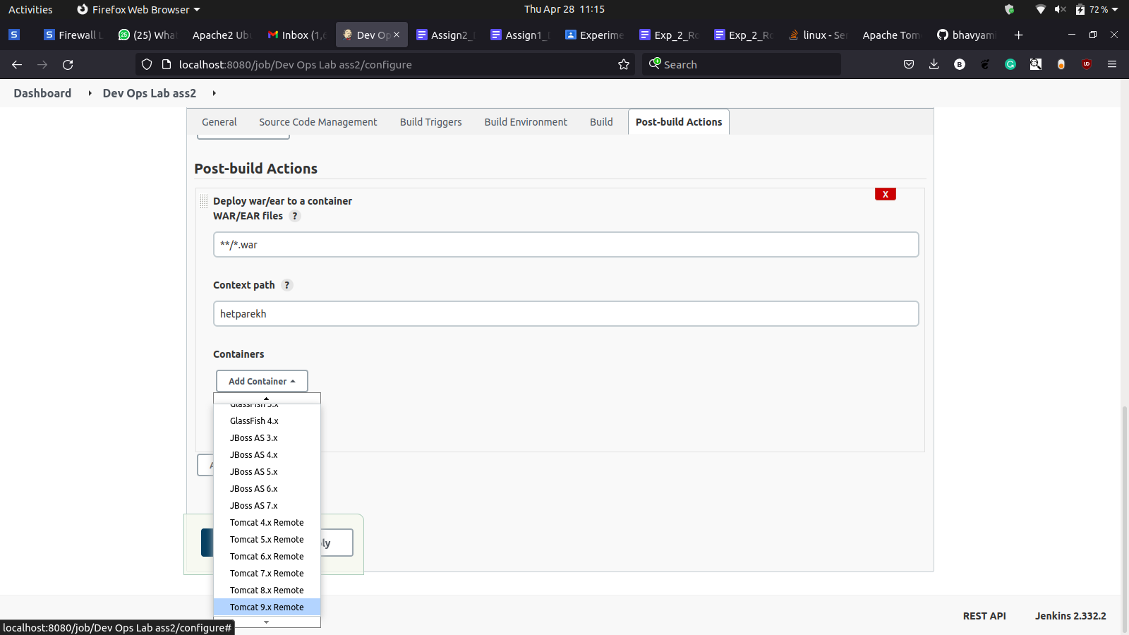

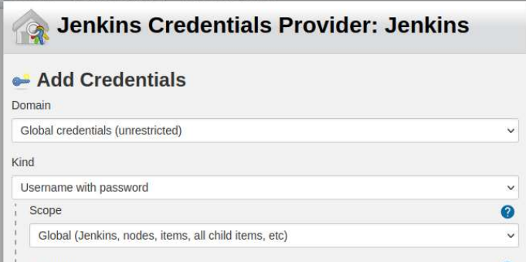

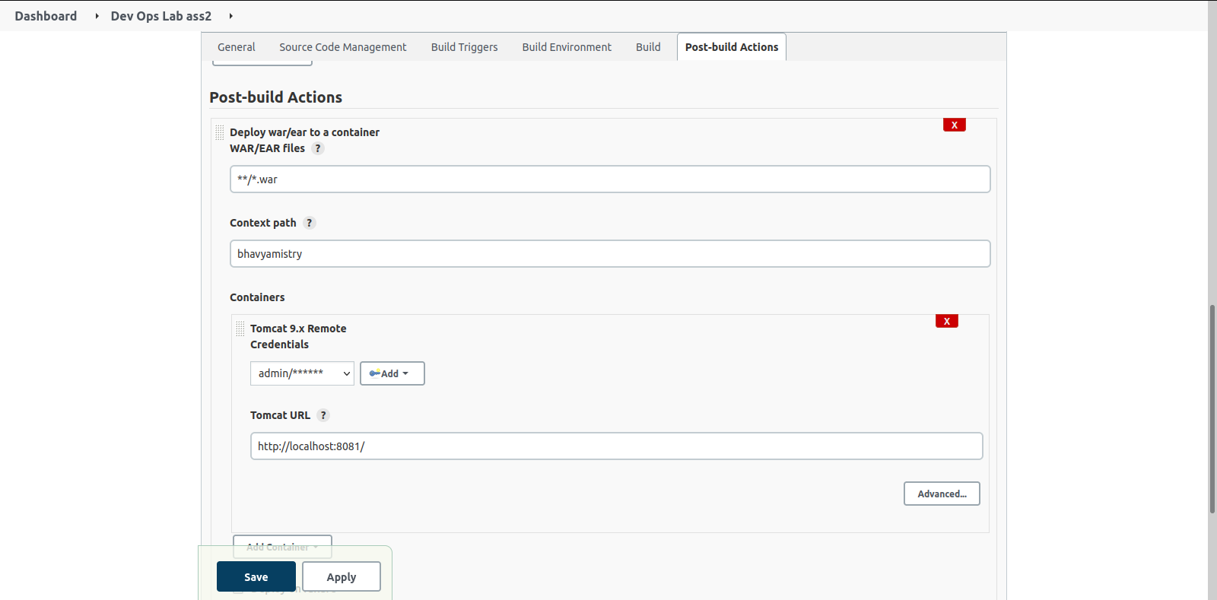

1. Building the Project

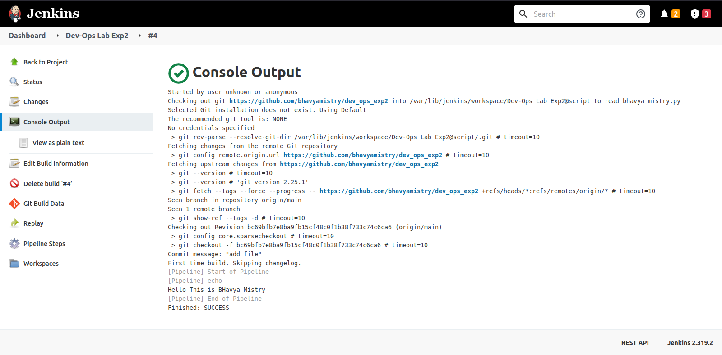

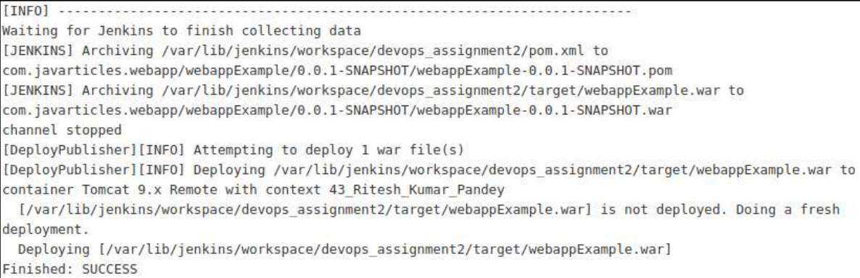



**Conclusion:**

Jenkins was configured to fetch code from GitHub repository, build and deploy the war file of a maven project to the tomcat server. This facilitates the continuous integration and continuous deployment of maven projects and reduces the manual work of the developers.